**3.Serverless Data Processing Pipeline**

Build a serverless pipeline for processing data (e.g., log processing or ETL jobs).

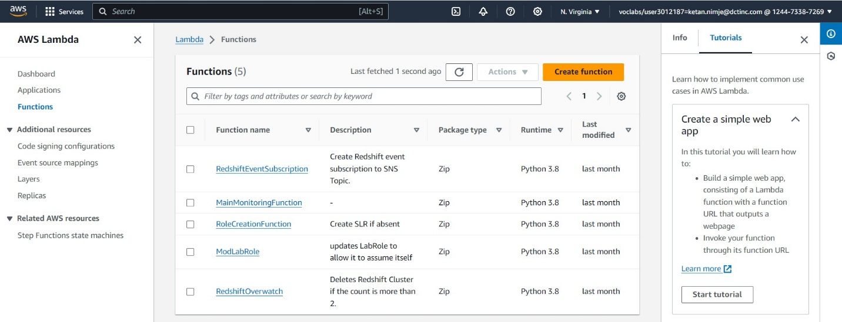

Creating a lambda function- demo lambda

Then creating buckets for storage.

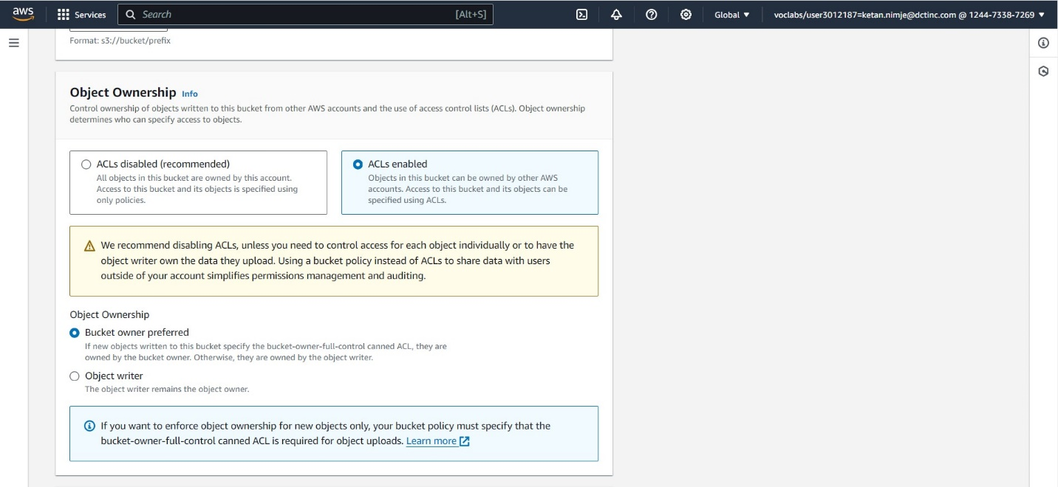

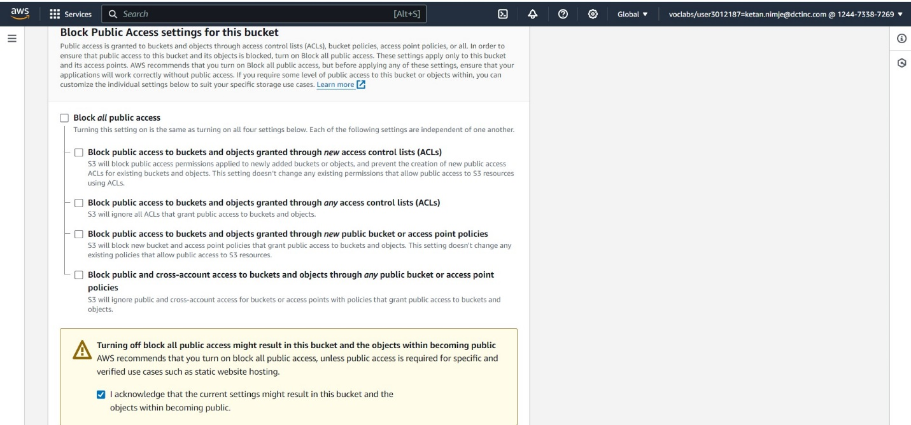

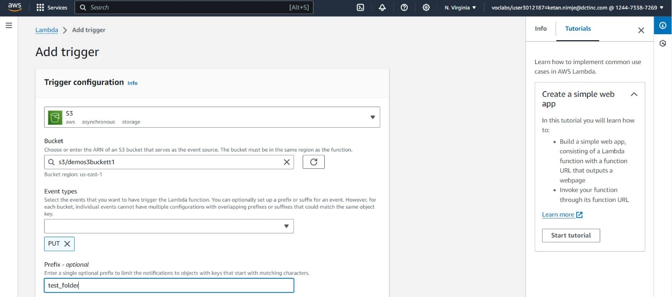

Adding S3 bucket as a trigger.

Code for triggering the lambda function when a file is uploaded into S3 bucket and then replicating the file into another bucket and creating a copy of same file in upper case in another bucket and then downloading the file into local machine.

Viewing the cloud watch logs to check the status of code.

This is the desired output.

2. Develop a serverless API using AWS Lambda and API Gateway.

Create lambda functions for each method i.e. get,put,delete,post

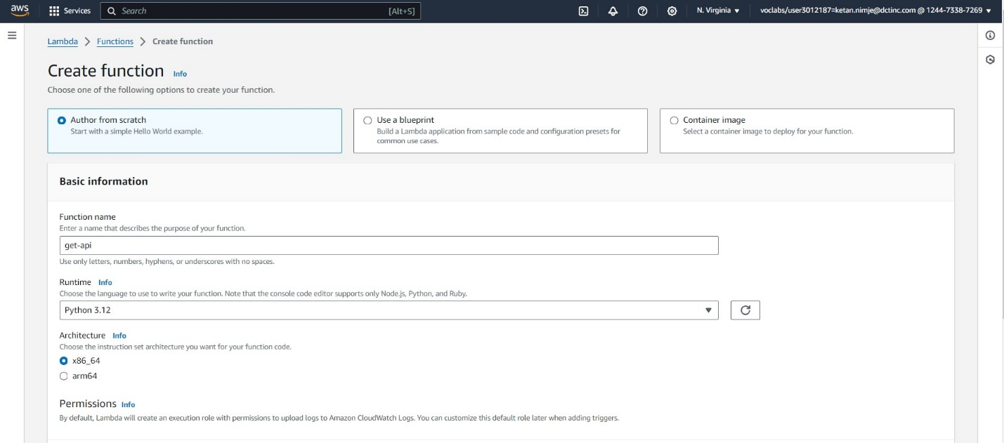

Repeat the same procedure for all the functions

Create Rest-api

Create resources

Create method for get, put, delete, post

Test the method

Deploy the api and check it on web



This is the result above.

Repeat the same procedure for all other methods, create them and test them in aws

Giving the input for post method

